**Name: Amanoh Ugochukwu Student ID: 10019995**

**WEATHER DROID  
 User Guide**

Step 1:

Download and install the .apk file to your phone’s SD card. You will need to allow for two permissions, INTERNET and SET_WALLPAPER.

Step 2:

Run the Weather Droid application which should have this icon



Step 3:

First time users will be directed to preferences to fill in a location and select a temperature unit.  
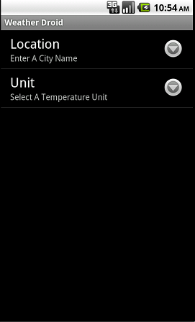

Be sure to check that your city name is spelt correctly and contains no special characters. When you are done click the back button.

Step 4:

Hitting the back button should take you to the main screen,  
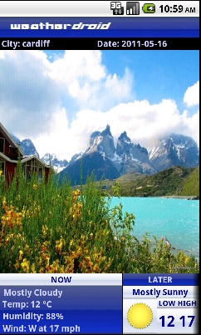

You should see the city name and date at the top left and right corners of your screen and an animated page which is more than half of the entire screen. These animations will change depending on the present weather condition.

The bottom area is horizontally scrollable contains the current weather report and the weather forecast for the rest of the days as well as the next 3 days.

Step 5:

Pressing the menu button gives you different options,  
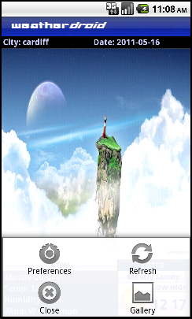

Preferences take you back to the preference screen, refresh updates the weather report, close will exit the application and gallery will take you to the Wallpaper Gallery.

Step 6:

Here you can look through our galaxy of weather related wallpapers,  
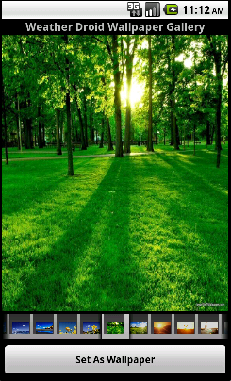

The topmost image displays the current wallpaper, the lower area is horizontally scrollable and contains all the wallpapers, you also have the option to set as your phone’s wallpaper by pressing the button.

Step 7:

If you get a message saying check user and internet settings  
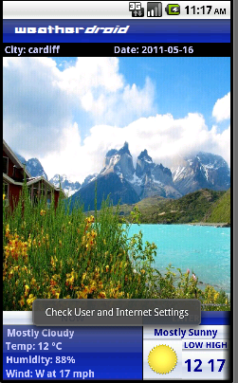

It means either you do not have internet connection or you have not filled in a correct city name or any at all.